Mr. Ayush

Top drivers by Miles:

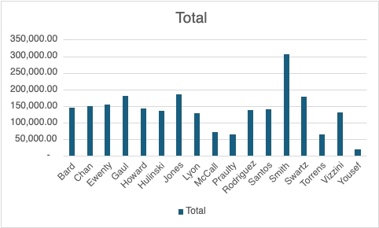

Scattered Chart for the Car Inventory:

